
Project design
AllThingsFitness

Malachi adebayo

Contents
Project Brief 2
Methodology 2
Design Documentation 2
Features 2
User Stories 3
System Architecture 3
System Type 3
Architecture Pattern 3
Frontend Approach 4
Backend Approach 4
Database Type 4
Entity Relationship Diagram 5
User Flow Diagram 6
UI/UX Design 7
Low fidelity prototype 7
Wireframes 8
High Fidelity Prototype 9

Project Brief
This project proposes the creation of an AI fitness platform that combines personalised fitness programs, smart nutrition plans, and dynamic conversational support in one system. It will use key metrics such as age, weight height, gender, gym status, fitness goals, dietary preferences/allergies and more to generate actionable workout routines and diet guidelines. This platform will adjust with user progress and give recommendations. Once the plan is created the user will have access to intelligent chatbots capable of answering fitness and nutritional questions, offering encouragement and providing guidance whenever needed. The system aims to digitalise coaching experience without high cost. It will break down complex information into simple steps, so users feel confident and capable. Merging artificial intelligence with evidence based fitness and nutrition strategies, improves access to quality wellness support for people of all backgrounds.

Methodology
The development process will follow a hybrid Agile approach, by combing some upfront planning with iterative, user centred development. This approach has been selected to balance flexibility and control required to complete the project.
Initially, a light planning phase will be conducted to define the requirements and objectives, architecture, data model and ethical considerations. This ensures that everything is clearly established before development begins. Altogether, this reduces the technical risk and provides a stable foundation.
Following this will be iterative Agile sprints. Each sprint will deliver a small component of the system, in order of the user journey. For example, the first sprint would be the login/registration component, as this comes in the user story. Features will be developed and tested, then refined, allowing the system to emerge based on the outcomes of testing and user feedback. This is essential for this system, as AI model behaviour and user interaction often requires adjustment.
Hybrid Agile is especially suitable for this project due to the experimental and ‘random’ nature of AI. As personalised feedback and nutrition recommendations are refined, feedback from testing can be incorporated without disrupting the entire system. This ensures that the platform remains adaptable while maintaining progress towards creating a deliverable product.

Design Documentation

Features
- Personalised workout plans based on user metrics and fitness goals
- Tailored nutritional guidance including calorie targets and meal suggestions
- Progress tracking with automated plan adjustments
- Integrated conversational chatbot for quick fitness and nutrition enquiries
- Motivational feedback and tips to help build consistent habits
- Educational advice on form, recovery and healthy choices
- Alerts and reminders to hold users accountable
It is important to recognise that long term health success is not just about giving people information, it’s about understanding their personal needs, helping them overcome challenges, and keeping them engaged through the entire journey. The features of the project have been established to follow these principles.

User Stories
A possible user story comes from a man named John. John is a below average height male, with class 1 obesity. John would be a primary target user, as he struggles from a medical condition which affects his ability to get into fitness. John says: “As an adult struggling from obesity, I want to receive a personal plan that matches my medical condition, goals, and dietary needs.” The system addresses this by generating tailored recommendations based on user provided metrics.
Another story comes from a woman called Jane. Jane is an average height and average weight woman, with no medical condition effecting her ability to do exercise which classifies her as a secondary target user. Jane says, “I want to get into fitness and to push myself to my limit, and also able to log my progress.” The system addresses this story by intaking logging and dynamically feeding the user with a new plan based on the input into the log.

System Architecture

System Type
For a health and fitness platform like the proposed software, a mobile application would typically be considered the most suitable type. Mobile apps offer potability, accessibility, and integration with features like notifications. However, given the scope of this project and my strengths, the proposed system will be implemented as a web application. This choice allows the platform to be developed more effectively and reliably within the project constraints, whilst still delivering the core functionalities. Modern web applications require no installation and are accessible from any device with a browser, making them convenient. It also fits in with rapid iteration and testing, which aligns well with the Hybrid Agile development approach. A web based implementation provides a foundation for the system, whilst leaving scope for future development. If extended, the platform could look to be adapted into a mobile app, to further enhance accessibility.

Architecture Pattern
A three tier architecture will be used because it separates the presentation layer, logic, and the data layer to improve scalability, maintainability and security. This structure suits the project by allowing the web interface, AI process and database to all operate independently, making the system easier to develop, test and extend. It also supports future expansion (like adding the mobile system) without having to redesign the systems core.

Frontend Approach
A single page approach would be ideal for this system. I’d look to use a modern framework like React as it enables a responsive and interactive user experience. The approach allows dynamic content updates without full page reloads, which is ideal for features such as progress tracking and AI chat.
The UI is dynamic and dashboard like, rather than static. It includes multiple form based interactions during the onboarding process, where users input registration, then health metrics. Once this is done, users will primarily interact with a dashboard style interface that presents personalised plans, progress tracking and the AI chat.

Backend Approach
The backend of the system will be developed using Python, with a Flask framework. This choice is driven by the AI-focused nature of the project, as Python offers the strongest ecosystem for data analysis, machine learning and health-related modelling. Using Python allows the recommendation logic and AI components to be implemented directly within the backend.

Database Type
A document based NoSQL database is the most suitable for this project. The system relies on flexible and evolving user data, which not always fit neatly into rigid table structures.

Integration
The system has been designed to integrate with a few external services to enhance functionality. The primary integration is with an AI service, which is accessed via a secure API from the backend to support personalised fitness and nutrition recommendation. User authentication is also handled through the backend using secure credentials and session handling. The architecture also allows for future integrations, like wearable device APIs.

Deployment
The system will be deployed on a cloud based hosting environment, allowing users access to the system through a browser without installation. The backend API will be deployed as a separate service, which maintains separation of components.

Entity Relationship Diagram
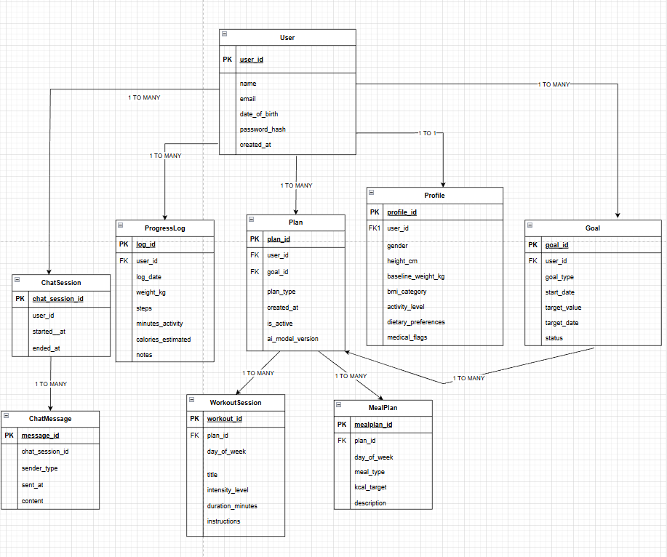
The ERD shows how the platform is structured and how the different parts of the system relate to one another. The user entity is the central point, linking all the major features. Each user has one profile which stores their health metrics and preferences, and they can have multiple plans and goals over time. A plan can generate related workout sessions and meal plans which defines the users ongoing fitness and nutrition guidance.

User Flow Diagram
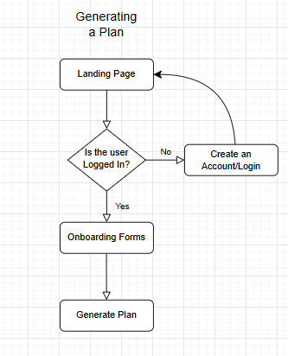
This diagram simply demonstrates the flow of a user generating a plan. The user will start on the landing page. Only if a user is logged in will they be able to access the onboarding forms. If not, the user will be redirected to the Login/Register Page. Then the user will finish the onboarding forms and be able to generate a plan.
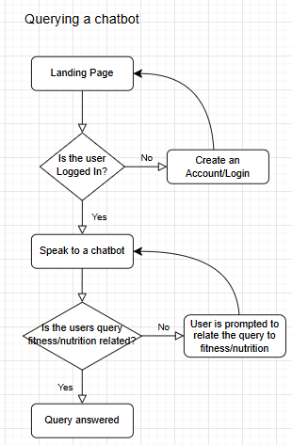
This diagram shows the flow of a user talking to one of the chatbots. The user will arrive on the landing page. Once the user presses on the speak to a chatbot button they will arrive on an empty chat, only if they are logged in. If they are not, they will be redirected to the login/registration page. Once on the chat, a user can enter a message and the chatbot will check whether its content is related to fitness and nutrition. If not, the user will be prompted to only enter fitness or nutrition enquiries. If it is related, the query will be answered.

UI/UX Design

Low fidelity prototype
The low fidelity prototypes were tested amongst secondary target users and refined based on feedback. Although some feedback was helpful, it was problematic to illustrate some features due to my artistic capabilities, which led to feedback being more based on the lack of clarity of my drawings.

Wireframes
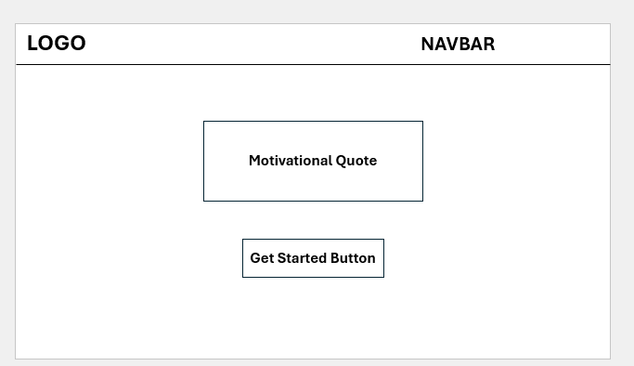
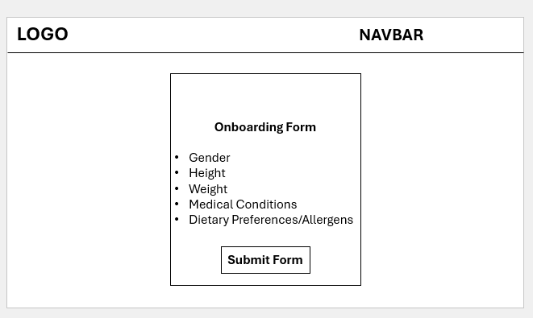
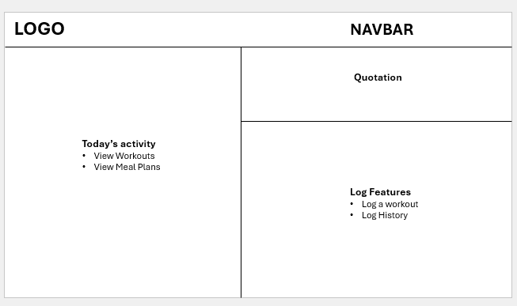

High Fidelity Prototype
Creating a high fidelity prototype with Figma allowed me to see what users really thought about the idea of the design, and I gained positive feedback from primary and secondary target users.
These are some of the prototypes I finalised, the Figma can be viewed here.
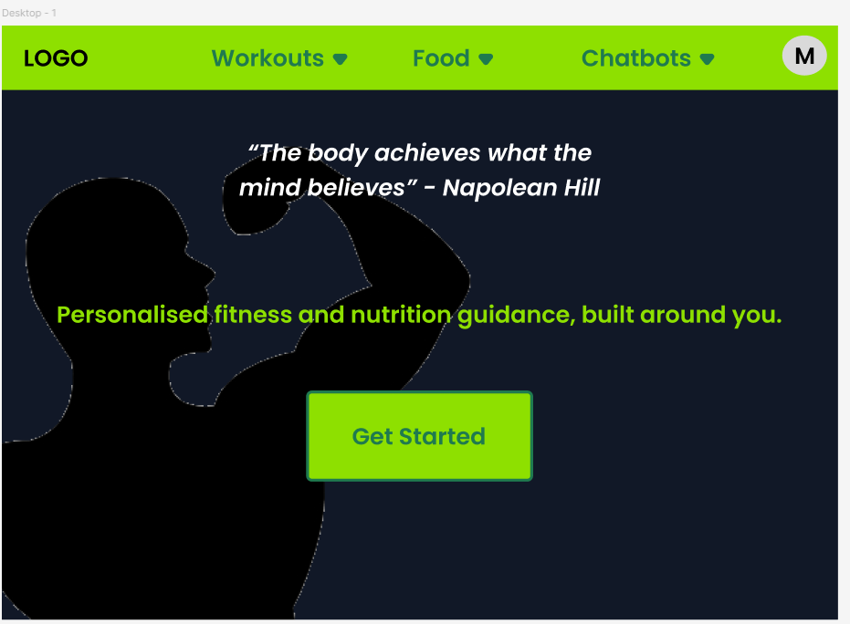
Here is the page that will take you to the onboarding form. Pressing get started will lead you to a form page that takes the users metrics so that their plan can be tailored specifically to them.
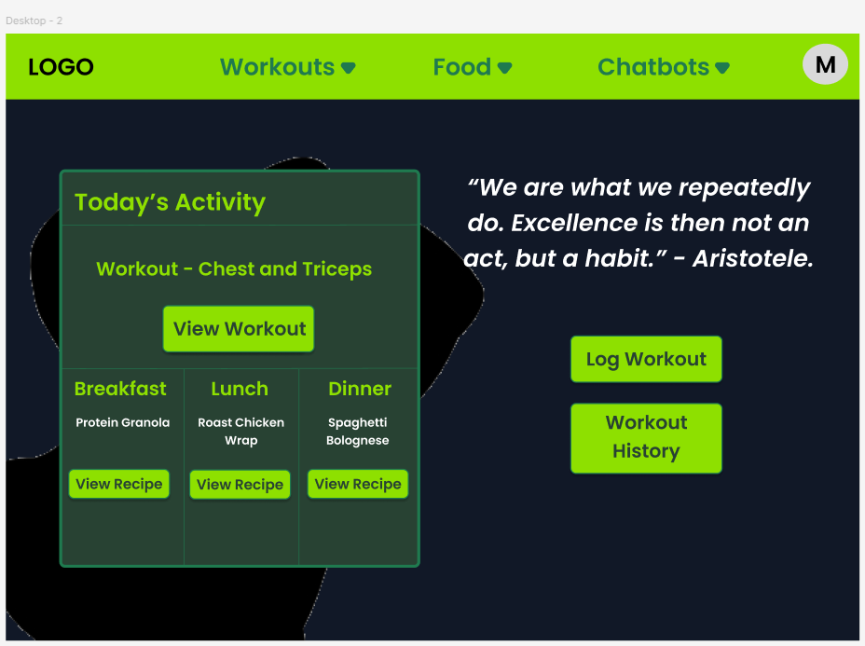
This page is the page that a regular user would see. Once logged in, the user sees all of todays activities on the left side of the page, alongside a log and history on the right. This is to please visual hierarchy, as a strong majority of people read from left to right, and putting content that a user will need to see for today on the left ensures that they see it first.

Conclusion
This design document outlines a justified AI fitness platform, using a three tier architecture to ensure the application is scalable and feasible. The design addresses ethical considerations and potential data security issues. Overall, the proposed solution demonstrates a clear path from concept to implementation, with strong potential to deliver meaningful health benefits.

